
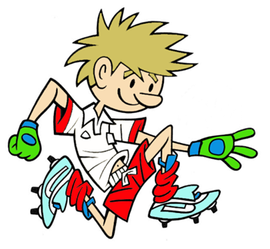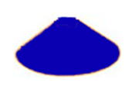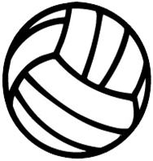
RULES - HOW TO PLAY

Hoop in middle of pairs

Start at red cone each

Pairs attempt to bounce ball into hoop

If successful move back a step to next dome

See who can move back the furthest still bouncing the ball into the hoop

Change position after getting to end line

Decide on how you score and win the game
FOCUS
In this activity we are developing the ability to use the Overhead Bounce Pass as a means of sending at a target
TARGET GAME: Game 3
GAME: Progression Bounce Ball

HARDER
- Smaller hoop
- Start by standing further from hoop
- Use Side of Head type of throw (Bring ball to Side of Head instead of Over Head)
- Dribble or bounce about the hoop and then stop and shoot

EASIER
- Bigger hoop as target
- Start beside the hoop
- Use Overhead Throw – Ball held above the head

COACHING POINTS
HEAD
- Receiving - Eyes on ball all the way into hands
- Sending – Keep eyes on hoop

HANDS
- Overhead - Big Hands around the ball and throw from above your head
- Side of Head - Hold ball at the side of the head and in front of shoulder of throwing hand
- Use the other hand to support the ball in front

FEET
- Stand one foot in front of other with opposite foot to throwing hand forward for better balance

EQUIPMENT

- Large Soft Ball

- Smaller Balls

- 1Hoop per pair

- Domes

Copyright Ulster Council GAA 2009

